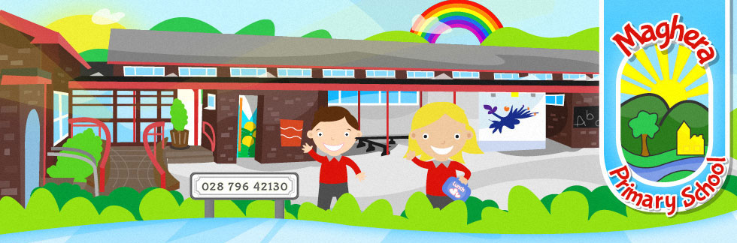
SOCIAL MEDIA POLICY FOR PARENTS

INTRODUCTION

The Internet provides various social media tools that enables users to interact with one another; current examples include social networking sites such as Facebook, Twitter, Snapchat and WhatsApp.

While Maghera Primary School recognises the benefits of these media, this policy sets out the principles for you as parents to follow when using social media. It is crucial that parents and the public at large have confidence in the school’s decisions and that the confidentiality of pupils and other staff as well as the reputation of the school is safeguarded.

This policy applies to all parents of pupils in Maghera Primary School. It covers parent’s personal use of social media in relation to interactions with any persons regarding the school. This policy applies to any personal webspace such as social networking sites, blogs, microblogs such as Twitter, chatrooms, forums, podcasts, open access online encyclopaedias and content sharing sites such as YouTube. The principles set out in this policy must be followed irrespective of the medium.

LEGAL FRAMEWORK

Parents should be aware that laws relating to libel, defamation, harassment and copyright may apply to information posted on social media.

PARENT GUIDANCE

Parents should be aware that what they publish on Social Media may be taken as published in the same way as publishing through other media. The publishing of content that is inappropriate, offensive, or likely to bring the staff member and /or the school into disrepute may lead to the school having to take appropriate action.

Parents must not use social media and the internet in any way to comment on or defame school staff, pupils or the school.

BREACHES OF THE POLICY

Any breach of this policy may lead to disciplinary or potential legal action being taken against the parents.
___________________________________________________________________________

ALL THOSE WITH PARENTAL RESPONSIBILITY
PLEASE COMPLETE AND RETURN THIS SLIP TO SCHOOL

I/We have received and read Maghera Primary School’s Social Media Policy, and will support this Policy. Please ensure all those with parental responsibility sign this form.

Child’s Name: _____________________________ Class: ______________________

Date: ___________________ Signed: ____________________________________

